Gini Index

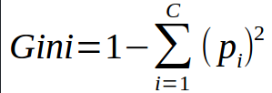
Gini Index is a metric to measure how often a randomly chosen element would be incorrectly identified. It means an attribute with lower gini index should be preferred.
Example: Construct a Decision Tree by using “gini index” as a criterion
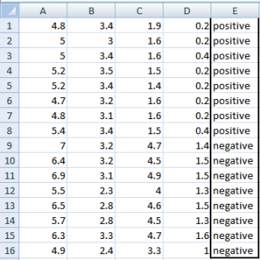
We are going to use same data sample that we used for information gain example. Let’s try to use gini index as a criterion. Here, we have 5 columns out of which 4 columns have continuous data and 5th column consists of class labels.
A, B, C, D attributes can be considered as predictors and E column class labels can be considered as a target variable. For constructing a decision tree from this data, we have to convert continuous data into categorical data.
We have chosen some random values to categorize each attribute:
A | B | C | D
>= 5 | >= 3.0 | >=4.2 | >= 1.4
< 5 | < 3.0 | < 4.2 | < 1.4



Gini Index for Var A
Var A has value >=5 for 12 records out of 16 and 4 records with value <5 value.
- For Var A >= 5 & class == positive: 5/12
- For Var A >= 5 & class == negative: 7/12
  - gini(5,7) = 1- ( (5/12)² + (7/12)² ) = 0.4860
- For Var A <5 & class == positive: 3/4
- For Var A <5 & class == negative: 1/4
  - gini(3,1) = 1- ( (3/4)² + (1/4)² ) = 0.375
By adding weight and sum each of the gini indices:

Gini Index for Var B
Var B has value >=3 for 12 records out of 16 and 4 records with value <5 value.
- For Var B >= 3 & class == positive: 8/12
- For Var B >= 3 & class == negative: 4/12
  - gini(8,4) = 1- ( (8/12)² + (4/12)² ) = 0.446
- For Var B <3 & class == positive: 0/4
- For Var B <3 & class == negative: 4/4
  - gin(0,4) = 1- ( (0/4)² + (4/4)² ) = 0

Gini Index for Var C
Var C has value >=4.2 for 6 records out of 16 and 10 records with value <4.2 value.
- For Var C >= 4.2 & class == positive: 0/6
- For Var C >= 4.2 & class == negative: 6/6
  - gini(0,6) = 1- ( (0/8)² + (6/6)² ) = 0
- For Var C < 4.2& class == positive: 8/10
- For Var C < 4.2 & class == negative: 2/10
  - gin(8,2) = 1- ( (8/10)² + (2/10)² ) = 0.32

Gini Index for Var D
Var D has value >=1.4 for 5 records out of 16 and 11 records with value <1.4 value.
- For Var D >= 1.4 & class == positive: 0/5
- For Var D >= 1.4 & class == negative: 5/5
  - gini(0,5) = 1- ( (0/5)² + (5/5)² ) = 0
- For Var D < 1.4 & class == positive: 8/11
- For Var D < 1.4 & class == negative: 3/11
  - gin(8,3) = 1- ( (8/11)² + (3/11)² ) = 0.397
wTarget  Positive Negative  A >= 5.0 5 7  <5 3 1  Ginin Index of A = 0.45825 | Target  Positive Negative  B >= 3.0 8 4  < 3.0 0 4  Gini Index of B= 0.3345
Target  Positive Negative  C >= 4.2 0 6  < 4.2 8 2  Gini Index of C= 0.2 | Target  Positive Negative  D >= 1.4 0 5  < 1.4 8 3  Gini Index of D= 0.273
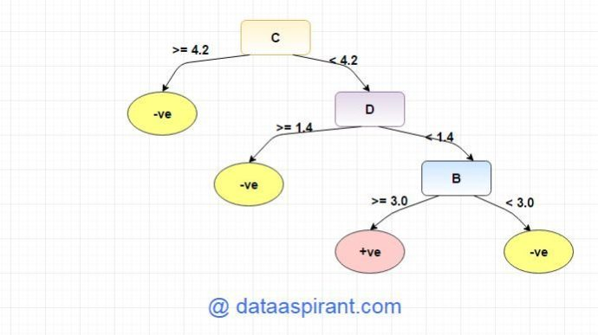
Entropy
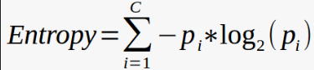

Example: Construct a Decision Tree by using “information gain” as a criterion
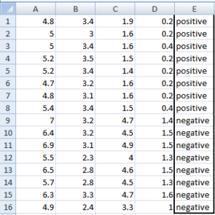We are going to use this data sample. Let’s try to use information gain as a criterion. Here, we have 5 columns out of which 4 columns have continuous data and 5th column consists of class labels.
A, B, C, D attributes can be considered as predictors and E column class labels can be considered as a target variable. For constructing a decision tree from this data, we have to convert continuous data into categorical data.
We have chosen some random values to categorize each attribute:
A | B | C | D
>= 5 | >= 3.0 | >= 4.2 | >= 1.4
< 5 | < 3.0 | < 4.2 | < 1.4
There are 2 steps for calculating information gain for each attribute:
- Calculate entropy of Target.
- Entropy for every attribute A, B, C, D needs to be calculated. Using information gain formula we will subtract this entropy from the entropy of target. The result is Information Gain.
The entropy of Target: We have 8 records with negative class and 8 records with positive class. So, we can directly estimate the entropy of target as 1.
Variable E
Positive | Negative
8 | 8
Calculating entropy using formula:
E(8,8) = -1*( (p(+ve)*log( p(+ve)) + (p(-ve)*log( p(-ve)) )
= -1*( (8/16)*log₂(8/16)) + (8/16) * log₂(8/16) )
= 1

Information gain for Var A
Var A has value >=5 for 12 records out of 16 and 4 records with value <5 value.
- For Var A >= 5 & class == positive: 5/12
- For Var A >= 5 & class == negative: 7/12
  - Entropy(5,7) = -1 * ( (5/12)*log2(5/12) + (7/12)*log2(7/12)) = 0.9799
- For Var A <5 & class == positive: 3/4
- For Var A <5 & class == negative: 1/4
  - Entropy(3,1) = -1 * ( (3/4)*log2(3/4) + (1/4)*log2(1/4)) = 0.81128
Entropy(Target, A) = P(>=5) * E(5,7) + P(<5) * E(3,1)
= (12/16) * 0.9799 + (4/16) * 0.81128 = 0.937745

Information gain for Var B
Var B has value >=3 for 12 records out of 16 and 4 records with value <5 value.
- For Var B >= 3 & class == positive: 8/12
- For Var B >= 3 & class == negative: 4/12
  - Entropy(8,4) = -1 * ( (8/12)*log2(8/12) + (4/12)*log2(4/12)) = 0.39054
- For VarB <3 & class == positive: 0/4
- For Var B <3 & class == negative: 4/4
  - Entropy(0,4) = -1 * ( (0/4)*log2(0/4) + (4/4)*log2(4/4)) = 0
Entropy(Target, B) = P(>=3) * E(8,4) + P(<3) * E(0,4)
= (12/16) * 0.39054 + (4/16) * 0 = 0.292905

Information gain for Var C
Var C has value >=4.2 for 6 records out of 16 and 10 records with value <4.2 value.
- For Var C >= 4.2 & class == positive: 0/6
- For Var C >= 4.2 & class == negative: 6/6
  - Entropy(0,6) = 0
- For VarC < 4.2 & class == positive: 8/10
- For Var C < 4.2 & class == negative: 2/10
  - Entropy(8,2) = 0.72193
Entropy(Target, C) = P(>=4.2) * E(0,6) + P(< 4.2) * E(8,2)
= (6/16) * 0 + (10/16) * 0.72193 = 0.4512

Information gain for Var D
Var D has value >=1.4 for 5 records out of 16 and 11 records with value <5 value.
- For Var D >= 1.4 & class == positive: 0/5
- For Var D >= 1.4 & class == negative: 5/5
  - Entropy(0,5) = 0
- For Var D < 1.4 & class == positive: 8/11
- For Var D < 14 & class == negative: 3/11
  - Entropy(8,3) = -1 * ( (8/11)*log2(8/11) + (3/11)*log2(3/11)) = 0.84532
Entropy(Target, D) = P(>=1.4) * E(0,5) + P(< 1.4) * E(8,3)
= 5/16 * 0 + (11/16) * 0.84532 = 0.5811575
Target  Positive Negative  A >= 5.0 5 7  <5 3 1  Information Gain of A = 0.062255 | Target  Positive Negative  B >= 3.0 8 4  < 3.0 0 4  Information Gain of B= 0.7070795
Target  Positive Negative  C >= 4.2 0 6  < 4.2 8 2  Information Gain of C= 0.5488 | Target  Positive Negative  D >= 1.4 0 5  < 1.4 8 3  Information Gain of D= 0.41189
From the above Information Gain calculations, we can build a decision tree. We should place the attributes on the tree according to their values.
An Attribute with better value than other should position as root and A branch with entropy 0 should be converted to a leaf node. A branch with entropy more than 0 needs further splitting.
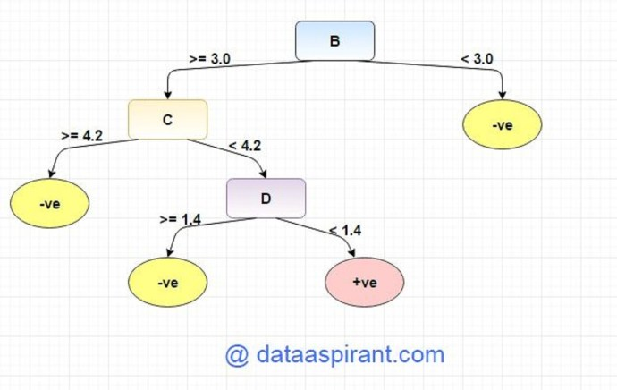

Tham khảo: https://dataaspirant.com/2017/01/30/how-decision-tree-algorithm-works/

